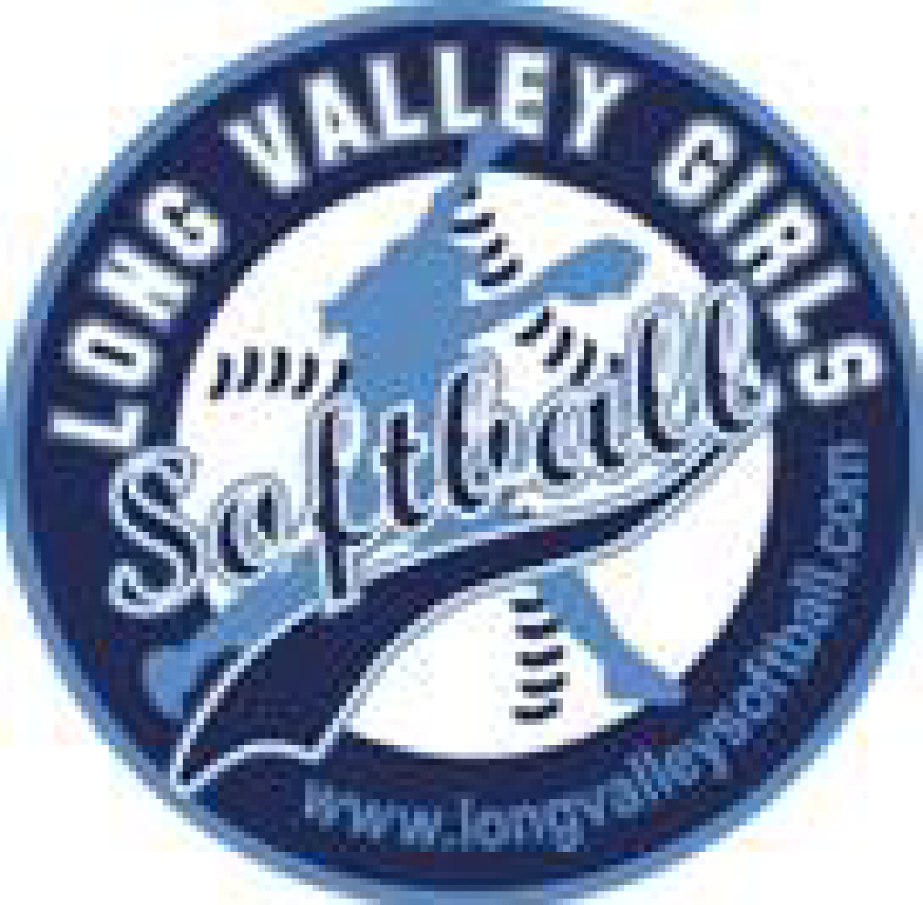
Long Valley Girls Softball Sponsorships

Remember the fun of playing softball or baseball as a kid? How nervous you felt at the first practice? How proud you were when you made the catch that won the game? Now it is your turn to help other young women experience the excitement of being on a Softball Team. We are looking for local businesses and families to sponsor the Long Valley Girls Softball Teams. This year we are offering three sponsorship options.

 | Grand Slam ($500) | Triple ($350) | Base  Hit ($100)
LVGSA Website | 
Name on a uniform shirt
Name on 4 x 5 Banner in the outfield of Palmer Park Fields
Name on Group Banner in outfield of Palmer Park Fields
Facebook Promotion
Specials included on our emails
(A great way to reach potential customers)

How to contribute – Please complete the attached form and forward it to:
LVGSA
P.O. Box 368
Long Valley, NJ 07853

Checks should be made out to LVGSA; please note the donation level in the memo line on your check.

Thank you,
LVGSA

Long Valley Girls Softball Association Sponsorships

Name of Sponsor: ______________________________________________
Daughters Name and Grade if Playing in the league: ________________
Address: ______________________________________________________
Email:_________________________________________________________
Phone:_________________________________________________________
Website:________________________________________________________

Any special offer to LVGSA families or players that we can include in the website post?______________________________________________________

Sponsors selecting the $500 level donation should include a business card or other printed material that contains their logo.

Please mail this sponsor form and check to:
LVGSA
P.O. Box 368
Long Valley, NJ 07853

Checks should be made out to LVGSA.
Please note the donation level in the memo line on your check.
Thank you.

